# Design of Reconfigurable MIMO Antenna Integrated with FSS With Enhanced Performance for 5G Application

Aritra Das (University Roll: - 12200319056)

Subhodeep Karmakar (University Roll: - 12200319039)

Chandrayee Dutta Chowdhury (University Roll: - 12200319049)

Subhrajit Nandy (University Roll: - 12200320062)

Under the guidance of

Dr. Juin Acharjee

Assistant Professor

Department of ECE

Submitted in partial fulfillment of the requirement of the Degree of Bachelor of Technology

of Maulana Abul Kalam Azad University (formerly West Bengal University of Technology). Kolkata



Department of Electronics and Communication Engineering

# St. Thomas’ College of Engineering and Technology

4 D.H. Road, Kolkata 700023

November, 2022

## Vision of the Department

* **To build a strong teaching and research environment to cater to the manpower needs in Industrial and Academic domains of the rapidly growing Electronics and Communication Engineering.**

## Mission of the Department

* **To produce certified industry-ready professional in Electronics and Communication Engineering, though innovative educational programs incorporating laboratory practices and project-based teaching-learning processes, in a modern environment.**
* **To create knowledge base of advanced technologies through research in the area of Electronics and Communication, for competitive and sustainable development of the country.**
* **To groom the department as a learning centre to inculcate advancement of technology in Electronics and Communication Engineering with social values and environmental awareness.**

## Program Specific Outcome (PSOs)

After completion of program graduate engineer would have:

* **PSO1. Professional skills: An ability to apply the knowledge in Electronics and Communication Engineering in various areas, like Communications, Signal processing, VLSI and Embedded Systems.**
* **PSO2. Competency: An ability to qualify at the State, National and International level competitive examinations for employment, higher studies and research**

## Project Outcome (PO)

**Format for Project Outcome:**

**After completion of the project, student will be able to:**

|  |  |  |
| --- | --- | --- |
| Outcome no. | Outcome Statements | Bloom’s Level |
| CO1 | Apply technical knowledge in the solution of complex real-life problems related to public health and safety, culture, society, and environment | 3 |
| CO2 | Review research literature and use the research-based knowledge to identify, formulate, and analyze the problem | 5 |
| CO3 | Design innovative solutions for complex engineering problems, which will be published as research paper or developed as a marketable product | 6 |
| CO4 | Apply modern tools to predict solution, design and develop the solution to problem | 4 |
| CO5 | Assess societal, health, safety, legal and cultural issues, and the consequent responsibilities relevant to the professional engineering practice. | 4 |
| CO6 | Understand the impact of the suggested solutions in environmental contexts, | 4 |
| CO7 | Apply ethical principles and commit to ethics and responsibilities related to engineering practice. | 3 |
| CO8 | Function effectively as a member or leader in a team. | 3 |

|  |  |  |
| --- | --- | --- |
| CO9 | Communicate effectively on professional activities with the team members, superiors and with society at large. | 3 |
| C10 | Plan, manage the project and control finance as a member and leader in a team. | 3 |
| C11 | Apply the knowledge acquired during the project, in future higher studies or any professional job or become entrepreneur to market products. | 4 |

Project Outcomes Vs Program Outcome and Program Specific Outcome (PO) Matrix:

|  |  |  |  |  |  |  |  |  |  |  |  |  |  |  |
| --- | --- | --- | --- | --- | --- | --- | --- | --- | --- | --- | --- | --- | --- | --- |
|  | PO1 | PO2 | PO3 | PO4 | PO5 | PO6 | PO7 | PO8 | PO9 | PO10 | PO11 | PO12 | PSO1 | PSO2 |
| CO1 |  | 2 | 3 | 4 | 3 |  |  |  | 3 |  | 2 | 2 | 3 | 2 |
| CO2 | 3 | 4 | 6 | 4 | 3 |  |  |  | 3 |  |  | 1 | 2 |  |
| CO3 | 3 |  | 6 | 3 |  | 3 | 3 | 3 | 3 |  |  |  | 3 |  |
| CO4 | 6 | 4 | 3 | 3 | 6 | 3 | 2 |  | 6 | 3 |  |  | 2 | 2 |
| CO5 |  |  | 3 |  |  | 3 | 3 | 2 | 2 |  | 3 | 1 |  |  |
| CO6 | 3 | 4 | 3 | 3 |  |  |  |  |  |  |  |  | 2 | 1 |
| CO7 | 3 | 2 | 3 |  |  |  |  |  |  | 2 |  |  |  |  |
| CO8 |  | 2 |  | 3 |  | 3 |  |  |  |  |  |  |  | 1 |
| CO9 | 3 |  |  | 3 |  |  |  |  |  | 2 |  |  | 2 |  |
| C10 |  | 2 | 3 |  |  | 3 |  |  |  |  | 3 |  |  |  |
| C11 | 3 |  | 3 |  |  |  | 3 |  |  | 2 |  |  | 3 | 1 |

# Certificate

**Department of Electronics and Communication Engineering St. Thomas’ College of Engineering and Technology**

This is to certify that the project entitled **“Design of Reconfigurable MIMO Antenna Integrated with FSS With Enhanced Performance for 5G Application”**, has been carried out by

**Aritra Das** (University Roll No.: - 12200319056),

**Chandrayee Dutta Chowdhury** (University Roll No.: - 12200319049),

**Subhodeep Karmakar** (University Roll No. - 12200319039),

**Subhrajit Nandy** (University Roll No.: - 12200320062),

Under my guidance during the year **July, 2022 to November, 2022** and accepted for partial fulfillment of the requirement of the Degree of Bachelor of Technology of Maulana Abul Kalam Azad University (formerly West Bengal University of Technology). Kolkata

**Dr. Juin Acharjee**

**Assistant Professor**

**Department of ECE**

……………………………………………….

**Signature of Project guide**

Dated:16/11/2022

# Acknowledgement

We would like to express our gratitude towards the faculties of the Department of Electronics & Communication Engineering of St. Thomas’ College of Engineering & Technology, whose constant guidance helped us to learn and analysed the topics in depth & have a handful of knowledge about the course. Besides, we would express our heartfelt gratitude to Dr. Juin Acharjee, our mentor in this project, whose constant monitoring, suggestions & support helped us gather knowledge about the project which should help us complete our project on time. We also got information about this project from some research papers on IEEE websites. We also thank our Head of the Department, Dr. Prasun Chowdhury who taught us about MIMO Antenna in Mobile Communication Network Class.





………………………………………………. ……………………………………………….

**Aritra Das Subhodeep Karmakar**

Dated: 15 / 11 / 2022 Dated: 15 / 11 / 2022



………………………………………………. ……………………………………………….

**Chandrayee Dutta Chowdhury Subhrajit Nandy**

Dated: 15 / 11 / 2022 Dated: 15 / 11 / 2022

**Contents**

|  |  |  |
| --- | --- | --- |
| **Chapter No.** | **Chapter Name** | **Page No.** |
|  |  |  |
|  |  |  |
| 1 | **Introduction** | 1 |
| 2 | **Background of the Project** | 2-8 |
|  |  |  |
| 3 | **Details of the Project** | 9-11 |
|  |  |  |
| 4. | **Results** |  |
|  |  |  |
| 5 | **Comments on the results** |  |
|  |  |  |
| 6. | **Conclusion** | 12 |
| 7 | **Reference** | 13 |

**Introduction**

In the past few years, there has been remarkable progress in the field of wireless communication. As the world is progressing by leaps and bounds, therefore it is evident to cope up with the data rate challenges faced by the telecommunication sector. With the increase in the number of user frequency, the allocation is becoming a challenge as the existing frequency bands are getting overcrowded. There is a certain limit of users that a single bandwidth channel can accommodate. An increase in the number of users also gives rise to co-channel interferences. Evolved video technologies like High Definition (HD) and Quadruple High Definition (QHD) resolutions require very high data rates, which are difficult to be handled by 3G and 4G technologies. So, there is a need for wider bandwidth and higher data rates to support the transmission of such kind of heavy volume data traffic. To cope with this problem, 5G reserved frequency bands are under research. The 50 provides the luxury of wider bandwidths and higher data rates and a greater number of frequency channels as compared to 3G and 4G; therefore, 5G would be more suitable for the users who demand greater data rates and wider bandwidths. Despite many desirable features, 5G has a serious low penetration power problem that signal fades away on the reaching to the receiver side from the transmitter side using one antenna. Multiple Input Multiple Output (MlMO) tool has proven to be a savior in this regard. MIMO technology is widely applied due to the high transmission rate and stable communication quality. By multiplying the number of antenna elements at both the receiver and transmitter side, we can get a better data rate and channel capacity. The 5G mm-Wave remote channel data transfer capacities will be multiple times more noteworthy than the present 40 Long-Term Evolution (LTE) 20 MHz cell channels. Since the frequencies shrivel by a reasonable size at mm-Wave when contrasted with the present 4G microwave frequencies, diffraction, and material penetration will bring about more prominent weakening, in this way hoisting the significance of line-of-sight (LOS) propagation, reflection, and dissipating. Over the past few years, many ideas have been put forward by many researchers and companies. In the current scenario, the existing literature using 2 x 2 or 4 x 4 MIMO antennas. No doubt about 5G effective communication, we require 8 x 8 antennas that bring high requirements as needed in 5G equipment. With the increasing number of antennas come greater challenges to the researchers in the antenna industry.We also use machine learning with this mimo antenna and use Iot application for future.

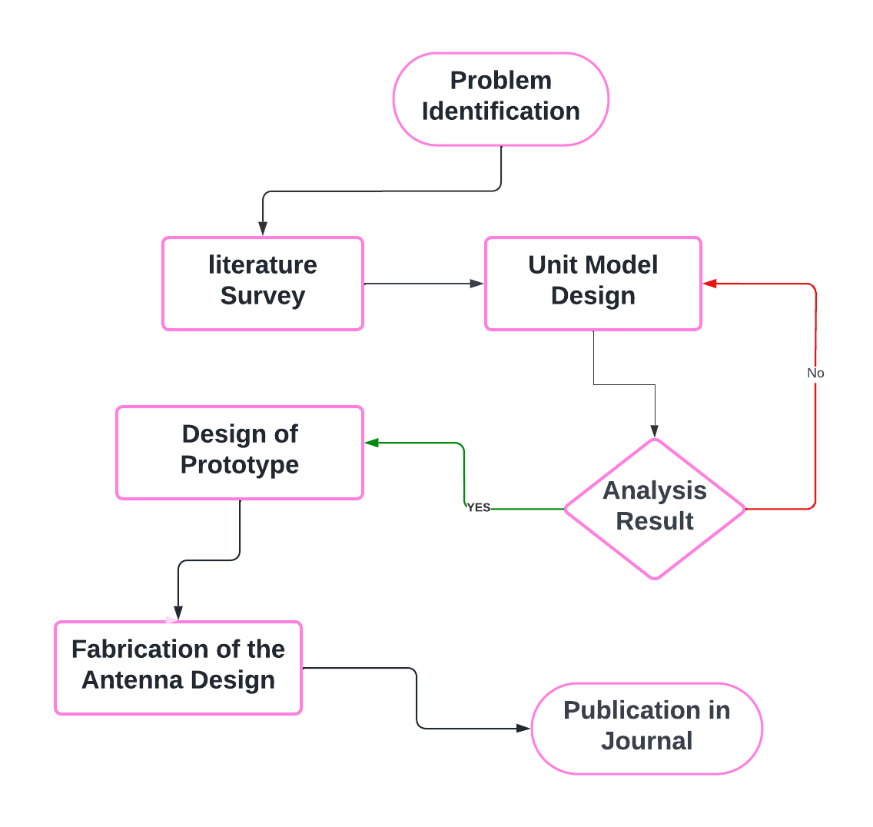Project Planning:

**Background of the Project:**

**Literature Survey**

|  |  |
| --- | --- |
|  |  |
| **A Compact Frequency-Reconfigurable Multiband LTE MIMO Antenna for Laptop Applications**  [Byeonggwi Mun](https://ieeexplore.ieee.org/author/37086631324); [Changwon Jung](https://ieeexplore.ieee.org/author/37277023800); [Myun-Joo Park](https://ieeexplore.ieee.org/author/37276966600); [Byungje Lee](https://ieeexplore.ieee.org/author/37281108800)  [IEEE Antennas and Wireless Propagation Letters](https://ieeexplore.ieee.org/xpl/RecentIssue.jsp?punumber=7727)  Year: 2014  [Volume:13](https://ieeexplore.ieee.org/xpl/tocresult.jsp?isnumber=6719497)  Journal or Article  Publisher: IEEE | From this paper we can know about a compact frequency-reconfigurable multiple-input–multiple-output (MIMO) antenna on a laptop is proposed for multiband LTE services. Each MIMO antenna consists of two planar inverted-F antenna (PIFA) elements, using a T-shaped dc line and two p-i-n diodes (D1 and D2), in conjunction with the proximity-coupled feed structure. By effectively minimising its dimension and its interference with antenna performance, the proposed T-shaped dc line is designed to fit within the proximity-coupled feed structure. The proposed MIMO antenna covers the LTE 17/13 bands (704–787 MHz) at State 1 (D1 and D2: ON state), and the LTE 20/7 bands (791–862 MHz, 2500–2690 MHz) at State 2 (D1 and D2: OFF state). The proposed antenna obtains high isolation (dB), low envelope correlation coefficient, and total efficiency of greater than 51%, for all operating frequency bands.  Fig. 1: - Structure of the proposed antenna for a laptop.  Fig. 2: - Radiation pattern (yz-plane) of the proposed antenna at (a) 720 MHz (State 1), (b) 810 MHz (State 2), and (c) 2600 MHz (State 2). |
| **An FSS Based Multiband MIMO System Incorporating 3D Antennas for WLAN/WiMAX/ 5G Cellular and 5G Wi-Fi Applications**  [Rashid Saleem](https://ieeexplore.ieee.org/author/37391651300); [Muhammad Bilal](https://ieeexplore.ieee.org/author/37587394400);  [Hassan Tariq Chattha](https://ieeexplore.ieee.org/author/37314144600);  [Sabih Ur Rehman](https://ieeexplore.ieee.org/author/37085426940);  [Anum Mushtaq](https://ieeexplore.ieee.org/author/37086833554);  [Muhammad Farhan Shafique](https://ieeexplore.ieee.org/author/37573062600)  [IEEE Access](https://ieeexplore.ieee.org/xpl/RecentIssue.jsp?punumber=6287639)  Year: 2019  [Volume:](https://ieeexplore.ieee.org/xpl/tocresult.jsp?isnumber=8600701) 7  Journal or Article  Publisher: IEEE | From this paper we can know about a compact 3-dimensional dual-element, multiband antenna for Multi-Input-Multi-Output (MIMO) applications is proposed in this paper. Folding technique along with various impedance matching structures are employed for miniaturisation and multiband operation while maintaining the desired S-parameter performance. A grid of Frequency Selective Surface (FSS) patch based decoupling structure is introduced to achieve measured isolation of more than 30 dB between antenna ports. In addition to this decoupling structure, a meandered line based defected ground plane configuration helps to retain the multiband response while maintaining the optimum isolation performance. This 3D-MIMO antenna is fabricated and measured for its performance in different bands of WLAN, WiMAX, 5G cellular and 5G Wi-Fi along with different MIMO performance parameters. The reported design is a suitable option for multiband MIMO applications for future wireless technologies.  Fig. 1: - Fabricated dual-element FMA MIMO. (a) Folded radiators/ armatures. (b) Ground plane with decoupling and feed line structures and (c) Dual-channel FMA-MIMO system.  (c)  (d)  Fig. 2: - Radiation patterns at (a) 2.4 GHz, (b) 2.95 GHz, (c) 3.6 GHz and (d) 5.5GHz. |
| **Beam-Tilting Endfire Antenna Using a Single-Layer FSS for 5G Communication Networks**  [Mohamad Mantash](https://ieeexplore.ieee.org/author/37594838600);  [Arun Kesavan](https://ieeexplore.ieee.org/author/37085754779);  [Tayeb A. Denidni](https://ieeexplore.ieee.org/author/37281294100)  [IEEE Antennas and Wireless Propagation Letters](https://ieeexplore.ieee.org/xpl/RecentIssue.jsp?punumber=7727)  Year: 2018  Volume: 17,  [Issue: 1](https://ieeexplore.ieee.org/xpl/tocresult.jsp?isnumber=8253707)  Journal or Article  Publisher: IEEE | From this paper we can know about a simple beam-tilting technique for an end fire antenna using only a single-layer frequency selective surface (FSS). The proposed approach is based on placing a parasitic FSS element under the antenna to tilt the beam in the desired direction. This is achieved by using a modified uniplanar compact FSS. To demonstrate the principle, the periodic structure is applied to a Yagi–Uda antenna operating in the millimetre-wave frequency band from 28 to 31 GHz. The measured results, by integrating the proposed FSS (one layer of 3 × 5-unit cells) under the directors of the antenna, show that at 30 GHz, the main beam radiation tilts the end fire direction (yz-plane) by +23° and –29° when the FSS structure is rotated by 90°, respectively. The simplicity of this method makes it suitable for 5G communication networks.    Fig. 1: - (a) Configuration of the proposed antenna on FSS (dimensions in mm).  (b) Equivalent *LC* circuit for the FSS.    Fig. 2: - Radiation patterns of the antenna for three different cases at: (a) 28 GHz and (b) 31 GHz; normalized: (c) simulation at 30 GHz and (d) measurement at 30 GHz. |
| **Frequency Reconfigurable Microstrip Loop Antenna Covering LTE Bands with MIMO Implementation and Wideband Microstrip Slot Antenna all for Portable Wireless DTV Media Player**  [Anup N. Kulkarni](https://ieeexplore.ieee.org/author/37955736900);  [Satish K. Sharma](https://ieeexplore.ieee.org/author/37270454300)  [IEEE Transactions on Antennas & Propagation](https://ieeexplore.ieee.org/xpl/RecentIssue.jsp?punumber=8)  Year: 2013  Volume: 61,  [Issue: 2](https://ieeexplore.ieee.org/xpl/tocresult.jsp?isnumber=6423915),  Journal or Article  Publisher: IEEE | From this survey we are able to know that how a microstrip slot antenna cover Digital TV (DTV) and frequency reconfigurable microstrip printed loop antenna operating at LTE bands 3 at 1.8 GHz and 7 at 2.6 GHz with multiple-input-multiple-output (MIMO) implementation are designed which can find applications in portable wireless DTV media players. The DTV antenna is matched from 496–862 MHz and LTE bands 3 and 7 from 1710–1880 MHz and 2500–2700 MHz, respectively, all considering matching criteria. Further, the LTE bands antennas are frequency reconfigurable antennas and its MIMO implementation shows an envelope correlation (EC) below 0.22 for both the LTE bands. Prototype antennas were fabricated and experimental verification was performed.  Fig. 1: - (a) Simulated antenna geometry showing the three antennas on a 150 mm x 150 mm ground plane. (b) Enlarged view for the reconfigurable loop associated with the antenna.    Fig. 2: - Measured normalized radiation patterns for the DTV antenna at 0.51 GHz (a) XZ cut, (b) YZ cut and at 0.70 GHz (c) XZ cut, (d) YZ cut. |
| **Low-Mutual-Coupling 60-GHz MIMO Antenna System with Frequency Selective Surface Wall**  [Reza Karimian](https://ieeexplore.ieee.org/author/38580722700); [Arun Kesavan](https://ieeexplore.ieee.org/author/37085754779); [Mourad Nedil](https://ieeexplore.ieee.org/author/37276349500); [Tayeb A. Denidni](https://ieeexplore.ieee.org/author/37281294100)  [IEEE Antennas and Wireless Propagation Letters](https://ieeexplore.ieee.org/xpl/RecentIssue.jsp?punumber=7727)  Year: 2017  [Volume: 16](https://ieeexplore.ieee.org/xpl/tocresult.jsp?isnumber=7855842)  Journal or Article  Publisher: IEEE | From this paper we can know about a new dielectric resonator antenna (DRA) for a millimetre-wave (mm-wave) multiple-input–multiple-output system is presented. Two approaches are exploited to reduce the mutual coupling between two antenna elements. First, a frequency selective surface (FSS) wall is inserted between the DRAs to reduce the free-space radiation. Then, two slots with different sizes acting like an LC resonator are etched from the common ground plane of the structure to reduce the surface current. The designed FSS has a wideband characteristic from 40 to 70 GHz. The FSS is optimised for the desired frequency of 57–63 GHz. A high-isolation of −30 dB is achieved when both FSS wall and slots are used. A prototype of the structure is fabricated and measured. The results give a low correlation coefficient (<5e–6) and a good agreement with simulation ones, indicating that the proposed antenna can provide spatial or pattern diversity to increase the data 1234capacity of wireless communication systems at mm-wave bands.   1. 123 (b) (c)   Fig. 1: - (a) Jerusalem cross on the top surface, (b) FAN shape on the bottom surface, (c) Perspective view of the unit cell    Fig. 2: - Simulated and measured radiation pattern of the proposed MIMO antenna (port 1) at two plane (a) E-Field (b) H-Field. |
| **Integration of 5G MIMO Antenna Array with Low Profile GSM Band Base-Station Antenna**  [Yufeng Zhu](https://ieeexplore.ieee.org/author/37086802535);  [Yikai Chen](https://ieeexplore.ieee.org/author/37407079100);  [Shiwen Yang](https://ieeexplore.ieee.org/author/37336142200)  Publisher: IEEE | In this paper we find, a dual-polarised 5G planar MIMO antenna array is integrated with one GSM band antenna element for multi-band base-station applications. Using frequency selective surface (FSS), a shared-aperture configuration covering 0.69-0.96 GHz band (B1) and the 3.3-5 GHz band (B2) is achieved. Compact size characteristic is realised by the capacitive loading effect of FSS. Due to the extremely limited space, feeding cables of B2 antenna array bring severe deteriorations on performance of B1 band antenna. A novel decoupling method which spirals coaxial cables with specific radium is proposed to eliminate these influences. On the other hand, port to port isolations in closely spaced B2 band antenna arrays are improved by disconnected baffle structures.   1. (b)   (c) (d)  Fig. 1: - Configuration of proposed dual-band antenna array. (a) Top view of the antenna array; (b) Side view of the antenna array; (c) Exploded 3D view of the spiral rising cables; (d) Exploded 3D view of the disconnected baffle structure. |
| **Two Port Multi-band MIMO Antenna with FSS Implementation**  [Zeba Parveen](https://ieeexplore.ieee.org/author/37086519723);  [Megha Dadel](https://ieeexplore.ieee.org/author/37860423600)  Publisher: IEEE | From this paper we understand how a low-profile two-port MIMO antenna is presented with a size of 50 mm × 82 mm × 1.6 mm for multiband applications. A FSS structure with partial ground has been introduced in this design. Three FSS strips have been used in parallel to antenna structure in the middle of the backside of the antenna. The substrate used is FR-4. The design has two triangle-shaped patches fed by 50 Ω microstrip transmission line which at its end has a thin strip line for impedance matching.   1. (b)   (c) (d)  Fig 1: - (a) Front view of proposed antenna, (b) Patch design, (c) Back view of proposed antenna, (d) FSS unit cell.    Fig. 2: - E-plane. Fig. 3: - H-plane. |
| **Performance Improvement of Multi-Band MIMO Dielectric Resonator Antenna System with a Partially Reflecting Surface**  [Gourab Das](https://ieeexplore.ieee.org/author/37085852245);  [Anand Sharma](https://ieeexplore.ieee.org/author/37085533500);  [Ravi Kumar Gangwar](https://ieeexplore.ieee.org/author/37398622200);  [Mohammad S. Sharawi](https://ieeexplore.ieee.org/author/37298515400)  Publisher: IEEE | From this paper we can know a partial reflector surface structure to improve the isolation and correlation coefficient values between cylindrical dielectric resonator antennas for MIMO applications. To achieve multiband characteristics, three different groups of cylindrical dielectric resonators cover 5.2 GHz, 5.5 GHz and 5.8 GHz bands respectively. Each group has two cylindrical dielectric resonators. So, three groups (i.e six cDRA) are placed at the top of the substrate and each cDRA is excited using a coplanar waveguide (CPW) fed conformal strip-line. To achieve improved isolation, three different phase gradient frequency selective surfaces (FSS) are designed which operate at 5.2 GHz, 5.5 GHz and 5.8 GHz bands, respectively. This phase gradient FSS is utilised as a superstrate above each group of DR elements. As a result, two different far-field patterns are achieved from each group of antenna elements which deliver improved isolation as well as low field correlation. This exclusive technique offers more than 12 dB of enhancement in isolation values and more than 70% improvement in envelope correlation coefficient (ECC) values, thus guaranteeing improved MIMO performance.  C:\Users\gourabecehit\Desktop\trans\prs_bottom_update.jpg   1. C:\Users\gourabecehit\Desktop\trans\prs_top.jpg (b)   Fig. 1 Configuration of the PRS (a) top view; (b) bottom view  F:\rad_pattern\port2.jpgF:\rad_pattern\port1.jpgF:\rad_pattern\port4.jpg  (a) (b) (c)  F:\rad_pattern\port5.jpgF:\rad_pattern\port3.jpgF:\rad_pattern\port6.jpg (d) (e) (f)  Fig. 2: - Simulated and measured far-field patterns at XZ-plane for different ports (a) port-1; (b) port-2; (c) port-3; (d) port-4; (e) port-5 and (f) port-6 |
| **An FSS based Correlation Reduction Technique for MIMO Antennas.**  [Tayyab Hassan](https://ieeexplore.ieee.org/author/37720861000); [Muhammad U. Khan](https://ieeexplore.ieee.org/author/38667670600); [Hussein Attia](https://ieeexplore.ieee.org/author/37531193400); [Mohammad S. Sharawi](https://ieeexplore.ieee.org/author/37298515400)  Publisher: IEEE | From this paper we can learn a new technique to reduce the correlation coefficient value between adjacent antenna elements in multiple-input-multiple-output (MIMO) configurations. Unlike the conventional works which utilise port isolation enhancement methods for this purpose, the proposed approach adopts decorrelation of the radiation patterns of individual elements. To achieve this, a phase-gradient frequency selective surface (FSS) is used as a superstrate above the antenna elements in a low profile FabryPerot (FP) cavity configuration. The effectiveness of the method is demonstrated by designing the system for a two-element MIMO antenna at 5.25 GHz. The proposed technique results in more than 95% reduction in the correlation coefficient value, thus projecting better MIMO performance.    Fig. 1. PRS unit cell geometry (W*SP* = 10.5 mm, W*SA* = variable)  Fig. 2. The phase-gradient PRS; (a) Bottom side and (b) Top side (L*s* = 105 mm). Numbers on the side correspond to the unit cell ID in Table I.    Fig. 3: - Radiation patterns of the fabricated antenna at 5.25 GHz (a) Without PRS and (b) With PRS |
| **An FSS Based Non-Planar Quad Element UWB-MIMO Antenna System**  [Muhammad Bilal](https://ieeexplore.ieee.org/author/37587394400);  [Rashid Saleem](https://ieeexplore.ieee.org/author/37391651300);  [Hammad. H. Abbasi](https://ieeexplore.ieee.org/author/37086159076); [Muhammad Farhan Shafique](https://ieeexplore.ieee.org/author/37573062600);  **Publisher: IEEE** | From this article we know about how a low profile, miniaturised four element UWB antenna for 4 port MIMO configuration is proposed. The MIMO Antenna elements are organised in a cuboidal geometry around a polystyrene block. An inverted L-Shaped structure provides decoupling among the antenna elements. This structure is FSS based and has slotted Y shapes etched in it. In addition to that, a square spiral parasitic structure improves input impedance matching over the desired frequency band. Antenna elements are realised on a low-profile FR-4 substrate having compact dimension of 32 mm × 36 mm × 1.5 mm. The proposed 3D UWB-MIMO system achieves good impedance matching and an effective isolation of 20 dB among antenna elements in most of the band. The reported configuration is suitable for non-planar/3D system-in-package applications where a planar arrangement of four elements is not possible due to size limitations.   1. (b)   (c)  Fig. 1: - Geometry of the proposed UWB-MIMO antenna. (a) front view (b) rare view (c) square spiral parasitic element (all dimensions are in millimeters).  (a)    (b)  Fig. 2: - E and H-plane plots. (a) 5 GHz (b) 10 GHz |
| **Two element MIMO antenna with frequency reconfigurable characteristics utilizing RF MEMS for 5G applications**  [Muhammad Mateen Hassan](https://www.tandfonline.com/author/Hassan%2C+Muhammad+Mateen), [Zeeshan Zahid](https://www.tandfonline.com/author/Zahid%2C+Zeeshan),, [Adnan Ahmed Khan](https://www.tandfonline.com/author/Khan%2C+Adnan+Ahmed),  Publisher: IEEE | From this paper we can know about a novel two-element MIMO reconfigurable antenna that can be switched among 600 MHz, 1.8, 2.4, 3.5, and 5.5 GHz bands. The proposed antenna consists of two semi-circular ring-shaped strip-lines and a rectangular slot on the top conducting layer of the substrate and a U-shaped slot, etched on the bottom side of the substrate. Frequency reconfigurable characteristics have been achieved using single pole four throw radio frequency micro-electro-mechanical system switch. The switch has been installed in the ground slot. The dimensions of the proposed MIMO antenna are 32 × 98 × 1 mm3. Measured isolation greater than 15 dB has been achieved in the operating bands. The calculated envelope correlation coefficient is less than 0.04 and the diversity gain in the operating bands is greater  Fig 1: - Proposed single antenna element (a) front view and back view and (b) evolution steps of proposed antenna with reﬂection coeﬃcient.  Fig 2: - Reﬂection coeﬃcient (dB) of the proposed single antenna element  Fig 3: - Radiation pattern of MIMO antenna (a) E-plane at 1.8 GHz, (b) H-plane at 1.8 GHz, (c) E-plane at 2.45 GHz, (d) H-plane at 2.45 GHz, (e) E-plane at 3.5 GHz, (f) H-plane at 3.5 GHz, (g) E-plane at 5.5 GHz, and (h) H-plane at 5.5 GHz |
| **Isolation Enhancement and Radar Cross Section Reduction of MIMO Antenna with Frequency Selective Surface**  [Sreenath Reddy Thummaluru](https://ieeexplore.ieee.org/author/37086335131);  [Raj Kishor Kumar](https://ieeexplore.ieee.org/author/37085611319);  [Raghavendra Kumar Chaudhary](https://ieeexplore.ieee.org/author/37863944400),  Publisher: IEEE | From this paper we can know about a new frequency selective surface (FSS) based isolation technique is proposed for multiple-input-multiple-output (MIMO) antennas. In the proposed method, a conventional ground plane monopole-based MIMO antenna is replaced with FSS to improve the isolation between the antenna elements as well as to reduce MIMO antenna radar cross section (RCS). In this paper, two FSS designs have been presented, and they are named as FSS and M\_FSS. M\_FSS is a slightly modified version of FSS. With FSS, isolation enhancement and RCS reduction have been achieved by altering antenna characteristics. With M\_FSS, the same can be achieved by preserving the antenna characteristics. The RCS reductions of 25 dBsm and 20 dBsm have been achieved by replacing the PEC ground plane with FSS and M\_FSS respectively. Also, by using the proposed FSS, a stable RCS reduction up to 600 for TE polarisation and up to 450 for TM polarisation has been achieved. The proposed MIMO antenna with FSS has been fabricated and the simulation results are experimentally verified.  G:\sreenath\MIMO_FSS\DATA plot\After ACCEPTANCE\1.tif  Fig. 1. Reference two-port antenna   1. (b) (c) (d)   Fig 2: - (a) Top view, (b) bottom view of the proposed MIMO antenna with FSS and its corresponding fabricated prototype (c) top view, (d) bottom view  G:\sreenath\MIMO_FSS\DATA plot\After ACCEPTANCE\7.tif   1. (b)   G:\sreenath\MIMO_FSS\DATA plot\After ACCEPTANCE\10.tif (c) (d)  Fig 3: - Measured radiation patterns of MIMO antenna with FSS at 5.43 GHz in (a)XZ-plane and (b) YZ-plane Comparing simulated radiation patterns of reference antenna and MIMO antenna with M\_FSS at 4.35 GHz in (c) XZ-plane (d) YZ-plane |
| **FSS and Meta-material Based Low Mutual Coupling MIMO Antenna Array**  [Sheng yuan Luo](https://ieeexplore.ieee.org/author/37086335924);  [Ying song Li](https://ieeexplore.ieee.org/author/37538177600); [Tao Jiang](https://ieeexplore.ieee.org/author/37279307300); [Beiming Li](https://ieeexplore.ieee.org/author/37087080320)  Publisher: IEEE | From this paper we can know about a multi-layers frequency selective surface (FSS) with meta-material is presented for reducing the mutual coupling in a MIMO antenna array, where the FSS elements are realised by using the periodic split ring resonators. The presented FSS with a meta-material is used as a suspended layer which is set over the MIMO antenna array. As for the meta-material with negative permeability, it is considered to filter out the electromagnetic wave propagation from the adjacent antenna element. As a result, the isolation between the MIMO antenna elements have been enhanced by introducing the proposed FSS and meta-material suspending layers over the MIMO antenna array, and about 20dB mutual coupling reduction has been achieved.  Fig 1: - Structure of the proposed MIMO antenna array (a) 3-D view of the MIMO array (b) Reference array (c) Elements in FSS and meta-material  Fig 2: - Radiation patterns of the proposed MIMO array |

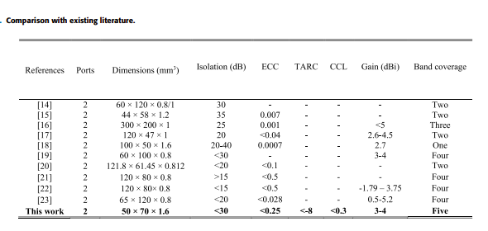

**Details of the Project**

This semester (7th semester) we have finished the literature survey from various IEEE website and we installed the software regarding this project which name is Ansys HFSS (high-frequency structure simulator) which is a commercial finite element method solver for electromagnetic structures from Ansys that offers multiple state-of-the-art solver technologies. After installing this software, we just learn to use this software and how can use this software to complete our project in the next semester we also watched some tutorial videos regarding this software and we also checked that the features of this software are matching with one research paper.

 We design an inset-feed microstrip antenna and watched how the radiation of this antenna looks like-

The screenshot of this antenna is presented below-

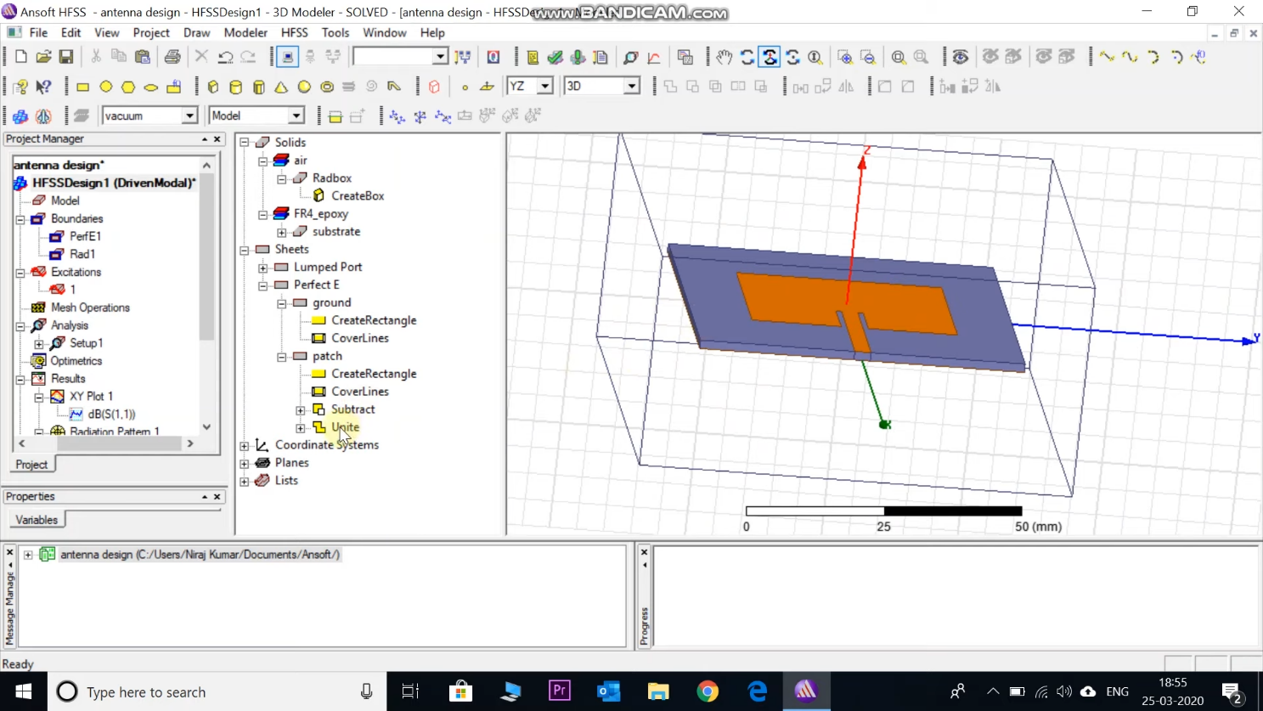

To check the resonance of the antenna we plot the s-parameter i.e., s (1,1) in dB.

In the below graph, we can see the resonance frequency is 2.39 GHz which is around 2.4GHz.

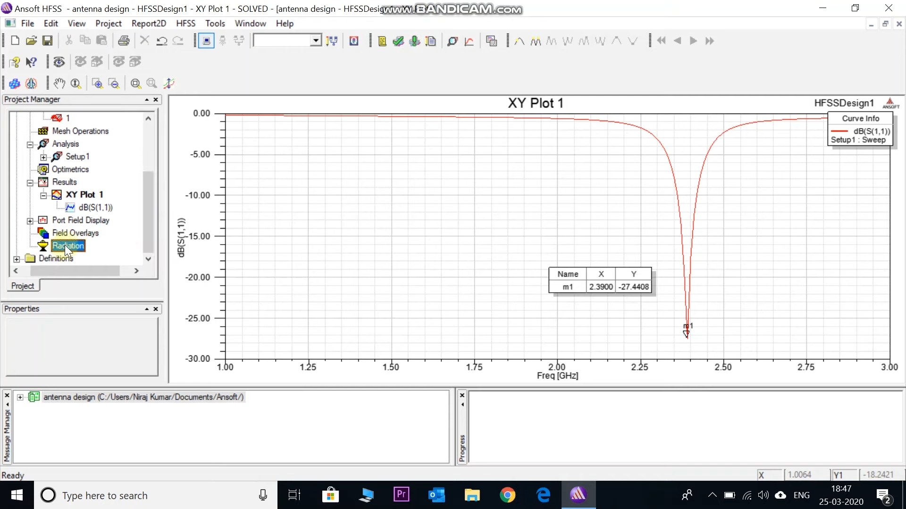

Here we can see a 3D polar plot of the radiation pattern of our antenna.

Maximum radiation is in the Z direction.

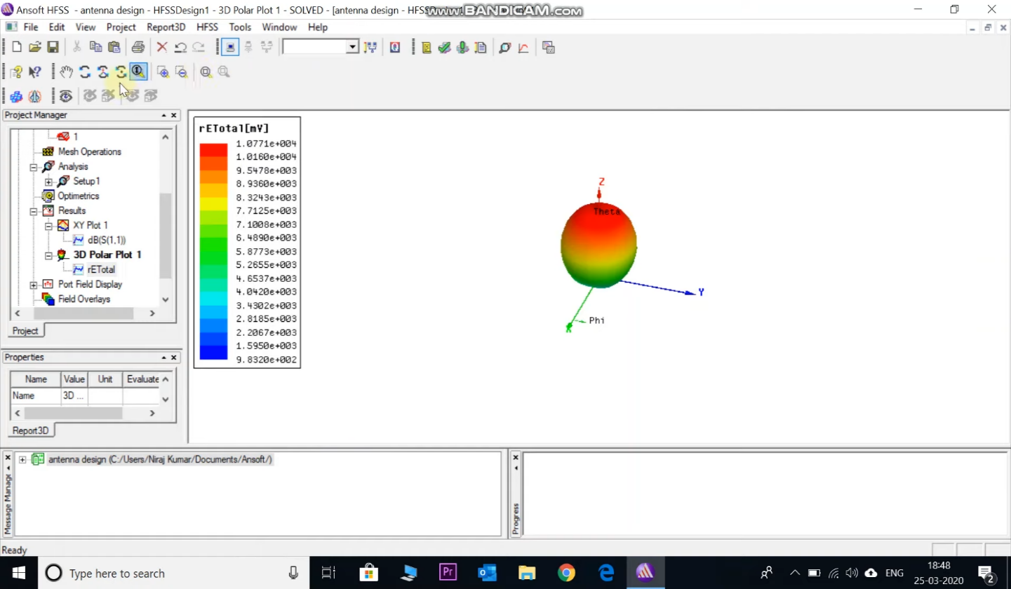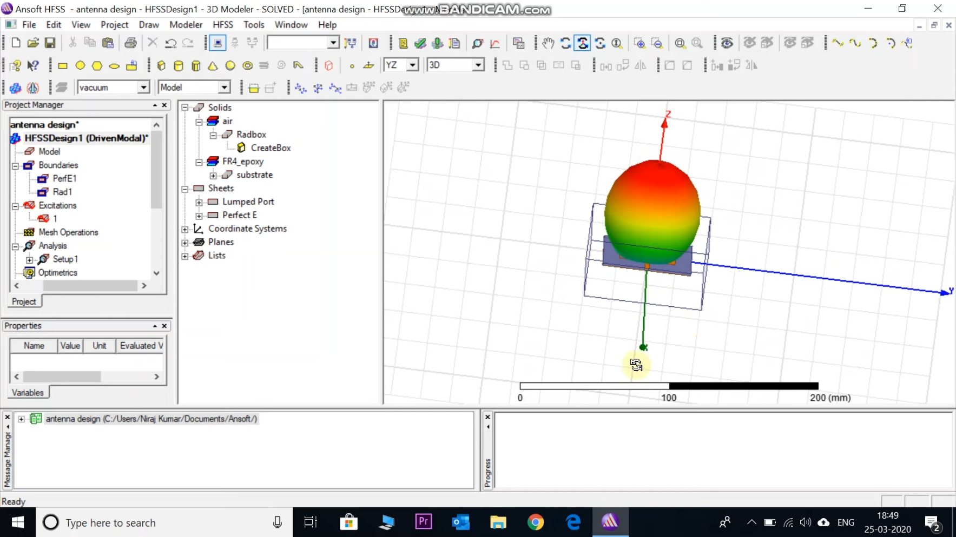

Here can be seen the electric field pattern –

We know that the E plane of the antenna is the plane that contains the electric field line in the direction of maximum radiation. So here the electric field is moving in the XZ plane and the direction of the maximum radiation of the Z axis so the E plane will be the XZ plane.

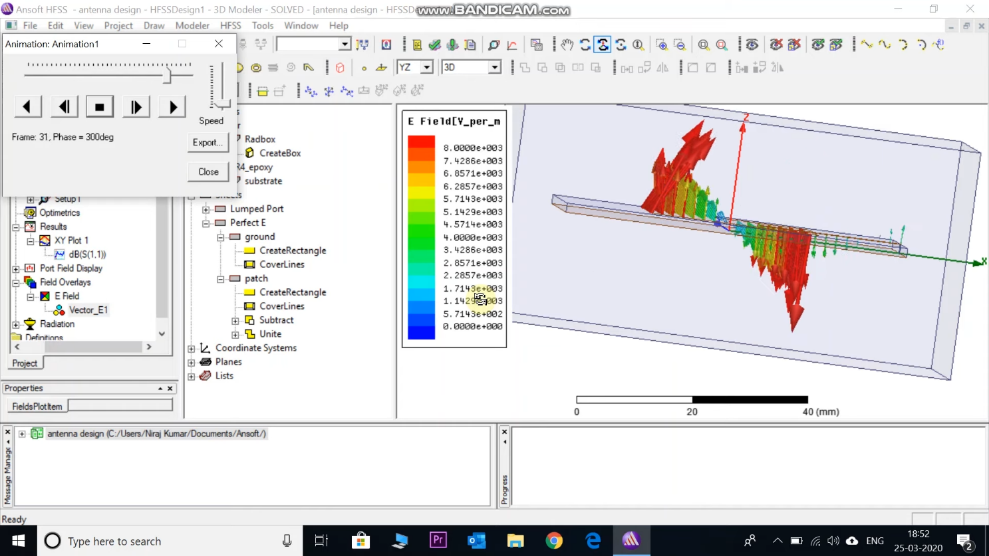

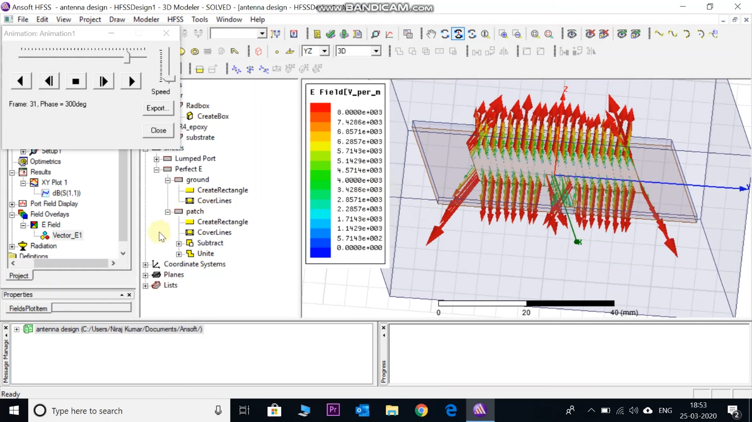

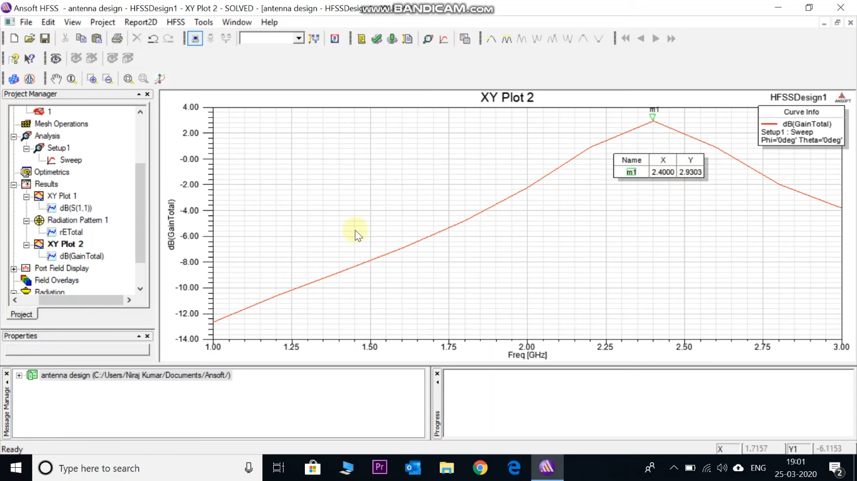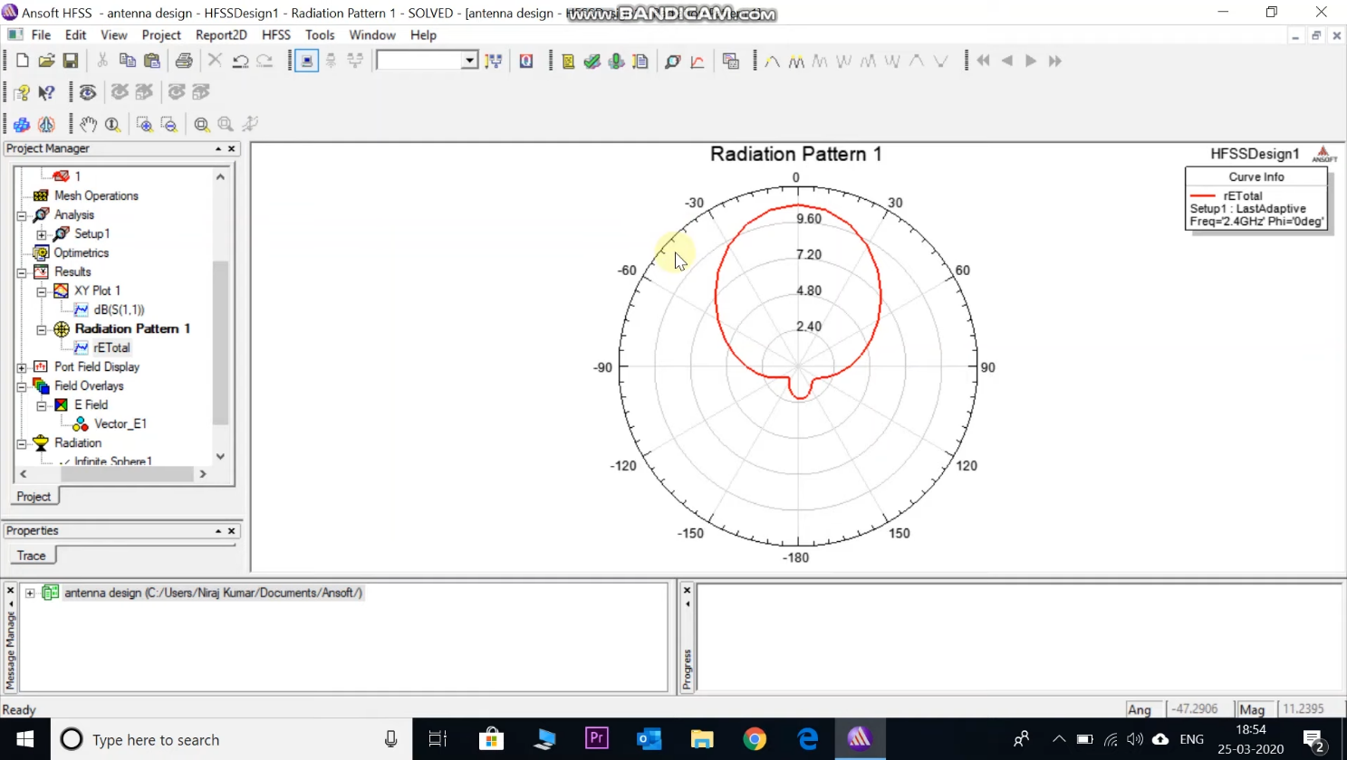

**Conclusion**

* So, in this semester (7th) we have just finished some pre-requisition works e.g.- literature survey, and software installation and we have studied this project and we know about the mimo (multiple input and multiple outputs) antenna and what is the applications of mimo (Multiple inputs and multiple outputs) antenna and this antenna can use in the 5G Communication system why 5G is much more useful compared to the 3G, and 4G Communication systems. In the next semester (8th) we will use HFSS software properly and we will definitely complete the whole project which should be more useful in our daily communication system.
* We can also use machine learning with this mimo antenna project in the future.
* We can also use IoT applications with this mimo antenna project in the future.
* We can also use a mimo antenna for making drones in future applications.

**Reference**

[1] A Compact Frequency-Reconfigurable Multiband LTE MIMO Antenna for Laptop Applications

[Byeonggwi Mun](https://ieeexplore.ieee.org/author/37086631324); [Changwon Jung](https://ieeexplore.ieee.org/author/37277023800); [Myun-Joo Park](https://ieeexplore.ieee.org/author/37276966600); [Byungje Lee](https://ieeexplore.ieee.org/author/37281108800)

[IEEE Antennas and Wireless Propagation Letters](https://ieeexplore.ieee.org/xpl/RecentIssue.jsp?punumber=7727)

Year: 2014 | [Volume: 13](https://ieeexplore.ieee.org/xpl/tocresult.jsp?isnumber=6719497) | Journal Article | Publisher: IEEE

[2]An FSS Based Multiband MIMO System Incorporating 3D Antennas for WLAN/WiMAX/ 5G Cellular and 5G Wi-Fi Applications

[Rashid Saleem](https://ieeexplore.ieee.org/author/37391651300);[Muhammad Bilal](https://ieeexplore.ieee.org/author/37587394400);[Hassan Tariq Chattha](https://ieeexplore.ieee.org/author/37314144600);[Sabih Ur Rehman](https://ieeexplore.ieee.org/author/37085426940);[Anum Mushtaq](https://ieeexplore.ieee.org/author/37086833554);[Muhammad Farhan Shafique](https://ieeexplore.ieee.org/author/37573062600) [IEEE Access](https://ieeexplore.ieee.org/xpl/RecentIssue.jsp?punumber=6287639) Year: 2019 | [Volume: 7](https://ieeexplore.ieee.org/xpl/tocresult.jsp?isnumber=8600701) | Journal Article | Publisher: IEEE

[3]Beam-Tilting Endfire Antenna Using a Single-Layer FSS for 5G Communication Networks

[Mohamad Mantash](https://ieeexplore.ieee.org/author/37594838600); [Arun Kesavan](https://ieeexplore.ieee.org/author/37085754779); [Tayeb A. Denidni](https://ieeexplore.ieee.org/author/37281294100)

[IEEE Antennas and Wireless Propagation Letters](https://ieeexplore.ieee.org/xpl/RecentIssue.jsp?punumber=7727)

Year: 2018 | Volume: 17, [Issue: 1](https://ieeexplore.ieee.org/xpl/tocresult.jsp?isnumber=8253707) | Journal Article | Publisher: IEEE

[4]Frequency Reconfigurable Microstrip Loop Antenna Covering LTE Bands With MIMO Implementation and Wideband Microstrip Slot Antenna all for Portable Wireless DTV Media Player

[Anup N. Kulkarni](https://ieeexplore.ieee.org/author/37955736900); [Satish K. Sharma](https://ieeexplore.ieee.org/author/37270454300)

[IEEE Transactions on Antennas and Propagation](https://ieeexplore.ieee.org/xpl/RecentIssue.jsp?punumber=8)

Year: 2013 | Volume: 61, [Issue: 2](https://ieeexplore.ieee.org/xpl/tocresult.jsp?isnumber=6423915) | Journal Article | Publisher: IEEE

[5]Low-Mutual-Coupling 60-GHz MIMO Antenna System With Frequency Selective Surface Wall

[Reza Karimian](https://ieeexplore.ieee.org/author/38580722700); [Arun Kesavan](https://ieeexplore.ieee.org/author/37085754779); [Mourad Nedil](https://ieeexplore.ieee.org/author/37276349500); [Tayeb A. Denidni](https://ieeexplore.ieee.org/author/37281294100)

[IEEE Antennas and Wireless Propagation Letters](https://ieeexplore.ieee.org/xpl/RecentIssue.jsp?punumber=7727)

Year: 2017 | [Volume: 16](https://ieeexplore.ieee.org/xpl/tocresult.jsp?isnumber=7855842) | Journal Article | Publisher: IEEE

[6]Integration of 5G MIMO Antenna Array with LowProfile GSM Band Base-Station Antenna

[Yufeng Zhu](https://ieeexplore.ieee.org/author/37086802535); [Yikai Chen](https://ieeexplore.ieee.org/author/37407079100); [Shiwen Yang](https://ieeexplore.ieee.org/author/37336142200)

Publisher: IEEE

[7]Two Port Multi-band MIMO Antenna with FSS Implementation

[Zeba Parveen](https://ieeexplore.ieee.org/author/37086519723); [Megha Dadel](https://ieeexplore.ieee.org/author/37860423600)

Publisher: IEEE

[8]Performance Improvement of Multi-Band MIMO Dielectric Resonator Antenna System with a Partially Reflecting Surface

[Gourab Das](https://ieeexplore.ieee.org/author/37085852245); [Anand Sharma](https://ieeexplore.ieee.org/author/37085533500); [Ravi Kumar Gangwar](https://ieeexplore.ieee.org/author/37398622200); [Mohammad S. Sharawi](https://ieeexplore.ieee.org/author/37298515400)

Publisher: IEEE

[9] An FSS based Correlation Reduction Technique for MIMO Antennas.

[Tayyab Hassan](https://ieeexplore.ieee.org/author/37720861000); [Muhammad U. Khan](https://ieeexplore.ieee.org/author/38667670600); [Hussein Attia](https://ieeexplore.ieee.org/author/37531193400); [Mohammad S. Sharawi](https://ieeexplore.ieee.org/author/37298515400)

Publisher: IEEE

[10] An FSS Based Non-Planar Quad Element UWB-MIMO Antenna System

[Muhammad Bilal](https://ieeexplore.ieee.org/author/37587394400); [Rashid Saleem](https://ieeexplore.ieee.org/author/37391651300); [Hammad. H. Abbasi](https://ieeexplore.ieee.org/author/37086159076); [Muhammad Farhan Shafique](https://ieeexplore.ieee.org/author/37573062600);

Publisher: IEEE

[11]Two element MIMO antenna with frequency reconfigurable characteristics utilizing RF MEMS for 5G applications

[Muhammad Mateen Hassan](https://www.tandfonline.com/author/Hassan%2C+Muhammad+Mateen), [Zeeshan Zahid](https://www.tandfonline.com/author/Zahid%2C+Zeeshan),, [Adnan Ahmed Khan](https://www.tandfonline.com/author/Khan%2C+Adnan+Ahmed),

Publisher: IEEE

[12]Isolation Enhancement and Radar Cross Section Reduction of MIMO Antenna with Frequency Selective Surface

[Sreenath Reddy Thummaluru](https://ieeexplore.ieee.org/author/37086335131); [Rajkishor Kumar](https://ieeexplore.ieee.org/author/37085611319); [Raghvendra Kumar Chaudhary](https://ieeexplore.ieee.org/author/37863944400),

Publisher: IEEE

[13] FSS and Meta-material Based Low Mutual Coupling MIMO Antenna Array

[Shengyuan Luo](https://ieeexplore.ieee.org/author/37086335924); [Yingsong Li](https://ieeexplore.ieee.org/author/37538177600); [Tao Jiang](https://ieeexplore.ieee.org/author/37279307300); [Beiming Li](https://ieeexplore.ieee.org/author/37087080320) | Publisher: IEEE